Request for Quotation (RFQ) - Shopping For Goods/ Procurement of furniture for House of Agriculture

Date: July 23, 2019

Project Title: Second Institutional Development and Agriculture Strengthening Project (MIDAS 2)
Source of Funding: World Bank loan
Loan No: 8820-ME
Contract Ref: MNE-MIDAS2-8820-ME-RFQ-G-19-1.2.2.3

Dear Supplier,

- You are invited to submit your price quotation for the supply of the following items:

Furniture for House of Agriculture

Information on technical specifications and required quantities are enclosed in Attachment 1 of RFQ.

2. You must quote for all the items combined under this Invitation. Price quotations will be evaluated for all the items together and contract awarded to the firm offering the lowest evaluated total cost of all the items.

3. Your price quotation in the form attached may be submitted by hand, mail, facsimile or electronically at the following address:
Ministry of finance
Technical Service Unit
Attn: Mirko Lješević
ul. Jovana Tomaševića 2 (Stara zgrada Vlade)
81000 Podgorica
e-mail: mirko.ljesevic@mif.gov.me
Telephone: +382 20 201 695
Fax: +382 20 201 698

4. The deadline for receipt of your quotation (s) by the Purchaser at the addressed indicated in this paragraph: August 26, 2019 at 12,00h.

5. Your quotation in duplicate and in English language, should be accompanied by adequate technical documentation and catalogue(s) and other printed material or pertinent information for each item quoted, including names and addresses of firms providing service facilities in Montenegro.

6. Your quotation(s) should be submitted as per the following instructions and in accordance with the attached Contract. The attached Terms and Conditions of Supply is an integral part of the Contract.

(i) PRICES: The prices should be quoted in EUR for the Total Cost at final destination at House of Agriculture in Bijelo Polje, address: ulica Slobode b.b, Bijelo Polje, Montenegro, which includes all taxes, VAT, customs, duties, inland transportation and insurance, loading and unloading and installation.

(ii) EVALUATION OF QUOTATIONS: Offers determined to be substantially responsive to the technical specifications will be evaluated by comparison of the total price at final destination as per para. 2 above.

In evaluating the quotations, the Purchaser will determine for each bid the evaluated price by adjusting the price quotation by making any correction for any arithmetical errors as follows:
(a) where there is a discrepancy between amounts in figures and in words, the amount in words will govern;
(b) where is a discrepancy between the unit rate and the line item total resulting from multiplying the unit rate by the quantity, the unit rate as quoted will govern;
(c) if a Supplier refuses to accept the correction, his quotation will be rejected.

(iii) AWARD OF PURCHASE ORDER: The award will be made to the bidder offering the lowest evaluated price and that meets the required standards of technical and financial capabilities. The successful bidder will sign a Contract as per attached form of contract and terms and conditions of supply.

(iv) VALIDITY OF THE OFFER: Your quotation(s) should be valid for a period of forty five (45) days from the deadline for receipt of quotation(s) indicated in Paragraph 5 of this Invitation to Quote.

7. Further information can be obtained from:
Ministry of Finance
Technical Service Unit
Attn: Mirko Lješević
ul. Jovana Tomaševića bb (Stara zgrada Vlade)
81000 Podgorica
e-mail: mirko.ljesevic@mif.gov.me
Telephone: +382 20 201 695
Fax: +382 20 201 698

8. Inspections and Audits

8.1 The Supplier shall carry out all instructions of the Purchaser which comply with the applicable laws where the destination is located.

8.2 The Supplier shall permit, and shall cause its Subcontractors and consultants to permit, the Bank and/or persons appointed by the Bank to inspect the Supplier’s offices and all accounts and records relating to the performance of the Contract and the submission of the bid, and to have such accounts and records audited by auditors appointed by the Bank if requested by the Bank. The Supplier’s and its Subcontractors and consultants’ attention is drawn to Clause 5 Fraud and Corruption of the Form of Contract, which provides, inter alia, that acts intended to materially impede the exercise of the Bank’s inspection and audit rights constitute a prohibited practice subject to contract termination (as well as to a determination of ineligibility pursuant to the Bank’s prevailing sanctions procedures).

9. Please confirm by fax/e-mail the receipt of this invitation and whether or not you will submit the price quotation(s).

Sincerely,
Mirko Ljesevic s.r.
_____________________
TSU Procurement officer

FORM OF CONTRACT

THIS AGREEMENT number MNE-MIDAS2-8820-ME-RFQ-G-19-1.2.2.3

made on _________, ___ 2019, between Ministry of Agriculture and Rural Development, Rimski Trg 46, 81000 Podgorica, Montenegro, represented by Mr. Milutin Simović MSc, Minister (hereinafter called “the Purchaser”) on the one part
and ______________________________________ (hereinafter called “the Supplier”) on the other part.

WHEREAS the Purchaser has invited quotation for Procurement of furniture for House of Agriculture, viz. Contract MNE-MIDAS2-8820-ME-RFQ-G-19-1.2.2.3, (hereinafter called “Contract”) and has accepted the Bid by the Supplier for the supply of goods under Contract at the sum of ____________ (___________________________) hereinafter called “the Contract Price”.

NOW THIS AGREEMENT witnessethes as follows:
- The following documents shall be deemed to form and be read and construed as part of this agreement, viz:
- Invitation to Quote; Term and Conditions of Supply, Technical Specification;
- Addendum (if applicable);
- Taking into account payments to be made by the Purchaser to the Supplier as hereinafter mentioned, the Supplier hereby concludes an Agreement with the Purchaser to execute and complete the supply of Contract and remedy any defects therein in conformity with the provisions of Contract.
- The Purchaser hereby covenants to pay in consideration of the goods supply and acceptance of Contract and remedying of defects therein, the Contract Price in accordance with Payment Conditions prescribed by Contract.

- Termination
4.1 Termination for Default

The Purchaser, without prejudice to any other remedy for breach of Contract, by written notice of default sent to the Supplier, may terminate the Contract in whole or in part:

if the Supplier fails to deliver any or all of the Goods within the period specified in the Contract, or within any extension thereof granted.

if the Supplier fails to perform any other obligation under the Contract; or

if the Supplier, in the judgment of the Purchaser has engaged in fraud and corruption, as defined in Clause 5 below, in competing for or in executing the Contract.
(b) In the event the Purchaser terminates the Contract in whole or in part, the Purchaser may procure, upon such terms and in such manner as it deems appropriate, Goods or Related Services similar to those undelivered or not performed and the Supplier shall be liable to the Purchaser for any additional costs for such similar Goods or Related Services. However, the Supplier shall continue performance of the Contract to the extent not terminated.
4.2 Termination for Insolvency.

The Purchaser may at any time terminate the Contract by giving notice to the Supplier if the Supplier becomes bankrupt or otherwise insolvent. In such event, termination will be without compensation to the Supplier, provided that such termination will not prejudice or affect any right of action or remedy that has accrued or will accrue thereafter to the Purchaser.
4.3 Termination for Convenience.

The Purchaser, by notice sent to the Supplier, may terminate the Contract, in whole or in part, at any time for its convenience. The notice of termination shall specify that termination is for the Purchaser’s convenience, the extent to which performance of the Supplier under the Contract is terminated, and the date upon which such termination becomes effective.

The Goods that are complete and ready for shipment within twenty-eight (28) days after the Supplier’s receipt of notice of termination shall be accepted by the Purchaser at the Contract terms and prices. For the remaining Goods, the Purchaser may elect:

to have any portion completed and delivered at the Contract terms and prices; and/or
      - to cancel the remainder and pay to the Supplier an agreed amount for partially completed Goods and Related Services and for materials and parts previously procured by the Supplier

Fraud and Corruption
- If the Purchaser determines that the Supplier and/or any of its personnel, or its agents, or its Subcontractors, consultants, service providers, suppliers and/or their employees has engaged in corrupt, fraudulent, collusive, coercive or obstructive practices (as defined in the prevailing Bank’s sanctions procedures), in competing for or in executing the Contract, then the Purchaser may, after giving 14 days notice to the Supplier, terminate the Supplier's employment under the Contract and cancel the contract, and the provisions of Clause 4 shall apply as if such expulsion had been made under Sub-Clause 4.1.

- Inspections and Audits

6.1 The Supplier shall carry out all instructions of the Purchaser which comply with the applicable laws where the destination is located

The Supplier shall permit, and shall cause its Subcontractors and consultants to permit, the Bank and/or persons appointed by the Bank to inspect the Supplier’s offices and all accounts and records relating to the performance of the Contract and the submission of the bid, and to have such accounts and records audited by auditors appointed by the Bank if requested by the Bank. The Supplier’s and its Subcontractors and consultants’ attention is drawn to Clause 5 Fraud and Corruption, which provides, inter alia, that acts intended to materially impede the exercise of the Bank’s inspection and audit rights constitute a prohibited practice subject to contract termination (as well as to a determination of ineligibility pursuant to the Bank’s prevailing sanctions procedures).

Signature and seal of the Purchaser:  FOR AND ON BEHALF OF  _______________________  Name of Authorized Representative | Signature and seal of the Suppler:  FOR AND ON BEHALF OF  ____________________________  Name of Authorized Representative

FORM OF QUOTATION

_________(Date)
To: Ministry of Finance
Technical Service Unit
Attn: Mirko Lješević
ul. Jovana Tomaševića br.2 (Stara zgrada Vlade)
81000 Podgorica, Montenegro
e-mail: mirko.ljesevic@mif.gov.me
Telephone: +382 20 201 695
Fax: +382 20 201 698

We offer to execute the Procurement of furniture for House of Agriculture, viz. Contract MNE-MIDAS2-8820-ME-RFQ-G-19-1.2.2.3. in accordance with the Conditions of Contract accompanying this Quotation for the Contract Price of _________________________(amount in words and numbers) (______________) EUR. We propose to complete the delivery of Goods described in the Contract within a period of not later than 45 calendar days from the Date of Signing of the Contract.

This Quotation and your written acceptance will constitute a binding Contract between us. We understand that you are not bound to accept the lowest or any Quotation you receive.

We hereby confirm that this Quotation complies with the Validity of the Quotation required by the proposal documents.

Authorized Signature:______________________________________
Name and Title of Signatory_________________________________
_________________________________

Name of Supplier:_______________________________________
Address: _______________________________________
_______________________________________
Phone Number ___________________

Fax Number, if any ___________________

Terms and Conditions of Supply

Project Name: Procurement of furniture for House of Agriculture
Purchaser: Ministry of Agriculture and Rural Development
Consignee: House of Agriculture in Bijelo Polje
Package No. 1

- Prices and Schedules for Supply
No. | Item | Pcs | Unit Price (includes all taxes, VAT, customs, duties, inland transportation and insurance)  (EUR) | Total Price at final destination (includes all taxes, VAT, customs, duties, inland transportation and insurance)  (EUR) | Delivery date
a) | b) | c) | d) | e)=c) x d) | f)
1 | Office cabinet dimensions 90x50x250 | 15 |  |  | Not later than 45 days after signing the Contract
2 | Office metal cabinet dimensions 90x45x190 | 16 |  |  | Not later than 45 days after signing the Contract
3 | Mask around the metal cabinets 95x50x250cm | 15 |  |  | Not later than 45 days after signing the Contract
4 | Mask around the metal cabinets 95x50x200cm | 1 |  |  | Not later than 45 days after signing the Contract
5 | Office chair | 27 |  |  | Not later than 45 days after signing the Contract
6 | Chair for guests | 46 |  |  | Not later than 45 days after signing the Contract
7 | Office desk dimensions 150x75x75 | 27 |  |  | Not later than 45 days after signing the Contract
8 | Office desk is of dimensions 120x60x75 | 13 |  |  | Not later than 45 days after signing the Contract
9 | Movable cassette under the desk with three drawers dimension 40x50x60cm | 27 |  |  | Not later than 45 days after signing the Contract
10 | Movable cassette next to the desk with three drawers dimension 80x50x60cm | 9 |  |  | Not later than 45 days after signing the Contract
11 | Office cabinet dimensions 60x50x250 | 6 |  |  | Not later than 45 days after signing the Contract
12 | Office cabinet dimensions 45x35x250 | 1 |  |  | Not later than 45 days after signing the Contract
13 | Trash can | 35 |  |  | Not later than 45 days after signing the Contract
14 | Metal stand for the computer cabinet | 27 |  |  | Not later than 45 days after signing the Contract
15 | Partitions between the tables | 25 |  |  | Not later than 45 days after signing the Contract
16 | The kitchen made of veneered chipboard (upper and down elements) | 1,6m |  |  | Not later than 45 days after signing the Contract
17 | Round stainless steel sink | 1 |  |  | Not later than 45 days after signing the Contract
18 | Built in fridge | 1 |  |  | Not later than 45 days after signing the Contract
19 | Hob of the cooker with two hotplates | 1 |  |  | Not later than 45 days after signing the Contract
20 | Movable metal archive | 6 |  |  | Not later than 45 days after signing the Contract
21 | White board for drawing | 2 |  |  | Not later than 45 days after signing the Contract
22 | Clothes coat hanger tip 1 | 13 |  |  | Not later than 45 days after signing the Contract
23 | Clothes coat nanger tip 2 | 9 |  |  | Not later than 45 days after signing the Contract
TOTAL:
{Note: In case of discrepancy between unit price and total derived from unit price, the unit price shall prevail}

- Fixed Price: The prices indicated above are firm and fixed and not subject to any adjustment during contract performance.

- The Purchaser reserves the right at the time of contract finalization to increase or decrease by up to 15% the quantity of goods and services originally specified without any change in unit prices as well as other terms and conditions.

- Delivery Schedule: The delivery should be completed as per above schedule but not exceeding 45 days from contract signature day. Delivery will be at the address of the House of Agriculture, ul Slobode b.b, Bijelo Polje, Montenegro.

- Insurance: The Goods supplied under the Contract shall be fully insured in a freely convertible currency against loss of damage incidental to manufacture or acquisition, transportation, storage and delivery. The insurance shall be in an amount equal to 110 percent of the total value of the Goods from «Warehouse» to «Warehouse» on «All risks» basis, including «War Risks». The Supplier shall arrange and pay for cargo insurance, naming the Purchaser as the beneficiary.

- Applicable Law: The Contract shall be interpreted in accordance with the laws of the Purchaser's country.

- Resolution of Disputes: The Purchaser and the Supplier shall make every effort to resolve amicably by direct informal negotiation any disagreement or dispute between them under or in connection with the Contract. In the case of a dispute between the Purchaser and the Supplier, the dispute shall be settled in accordance with the country procedures.

- Delivery and Documents: Upon shipment, the Supplier shall notify the Purchaser and the Insurance Company by cable of fax the full details of shipment, including purchase order number, description of goods, quantity, the vessel, the Shipping and Forwarding Receipt from freight Company showing full details, port of loading, date of shipment, port of discharge, etc. The Supplier shall mail the following documents to the Purchaser, with a copy to the Insurance Company:
- copies of the Supplier’s invoice showing goods’ description, quantity, unit price, and total amount;
- duplicate air/ truck transport document and/ or duplicate of railway transport document, and/or duplicate FCR ( Forwarders Certificate of Receipt) in 1 Original and 2 Copies marked «freight prepaid»;
- copies of the packing list identifying contents of each package;
- manufacturer's or supplier's warranty certificate;
- certificate of origin;
- certificate of quality.

The above documents shall be received by the Purchaser at least one week before arrival of the goods at the port of place of arrival and, if not received, the Supplier shall be responsible for any consequent expenses.

9. Payment for your invoice will be made as follows: 100% against delivery of shipping documents and acceptance of goods, within thirty (30) days after the date of the Acceptance Certificate for the respective delivery, issued by the Purchaser.

- Warranty: Goods offered should be covered by manufacturer’s warranty for at least 12 months from the date of delivery to the Purchaser.

Packaging and Marking Instructions: The Supplier shall provide standard packing of the Goods as required to prevent their damage or deterioration during transit to their final destination, as indicated in the Contract.

- Defects: All defects will be corrected by the Supplier without any cost to the Purchaser within 30 day from the date of notice by Purchaser. Name and address of service facility which the defects are to be corrected by the supplier within the warranty period:
Address _______________
______________________

- Force-Majeure: The supplier shall not be liable for penalties or termination for default if and to the extent that its delay in performance or other failure to perform its obligations under the Contract is the result of an event of Force-Majeure.

For purposes of this clause, “Force-Majeure” means an events beyond the control of the Supplier and not involving the Supplier’s fault or negligence and not foreseeable. Such events may include, but not restricted to, act of Purchaser in its sovereign capacity, wars or revolutions, fires, floods, epidemics, quarantine restrictions, and freight embargoes.

If a Force-Majeure situation arises, the Supplier shall promptly notify the purchaser in writing of such condition and the cause thereof. Unless otherwise directed by the Purchaser in writing, the Supplier shall continue to perform its obligations under the Contract as far as is reasonably practical, and shall seek all reasonable alternative means for performance not prevented by Force-Majeure event.

- Required Technical Specifications
(i) General Description
(ii) Specific details and technical standards
(iii) Performance Parameters
Supplier confirms compliance with above specifications {In case of deviations supplier to list all such deviations}.

- Failure to Perform: The Purchaser may cancel the Agreement if the Supplier fails to deliver the Goods, in accordance with the above terms and conditions, in spite of a 21 day notice given by the Purchaser, without incurring any liability to the Supplier.

NAME OF SUPPLIER________________________________________________
Authorized Signature________________________________________
Place:
Date:
Attachment 1
Technical Specification

Bidder shall submit required certificates, catalogue, and other relevant documents to prove that offered materials satisfy requirements in Technical specification.
 |  | Equipment
1.000 | : | PL1 90x50x250cm  Office cabinet. Office cabinet is of dimensions 90x50x250. The construction of the cabinet is of the chipboard 18mm thick, design is selected by the user. The inside of the cabinet is with 5 shelves. The front of the cabinet are two doors to lock. Handles are made of plastic or aluminum. Calculation per piece . The price includes the purchase and installation. | 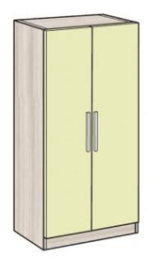
 |  |  | pcs | 15.00
2.000 | : | PP 90x45x190cm  Office metal cabinet is of the dimensions 90x45x190. Manufactured in accordance with DIN 4102standard, with fire resistance of 30 minutes. Cabinet has four removable shelves. The cabinet is made of sheet metal with mineral flame retardant filling. Keyhole with a double knurled/treated key. Calculation per piece. The price includes the purchase and installation. | 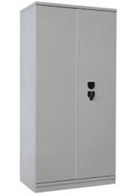  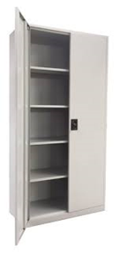
 |  |  | pcs | 16.00
3.000 | : | Mask around PP 95x50x250cm  Mask around the metal cabinets. The corpus is of chipboard with the thickness of 18 mm, design and color are selected by the user. Inside the mask there is a shelf above the metal cabinet. Dimensions of the mask are 95x50x250. Calculation per piece. The price includes the purchase and installation. | 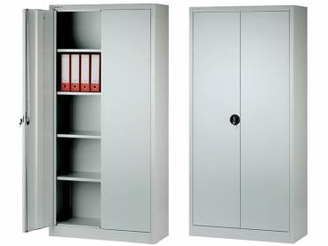  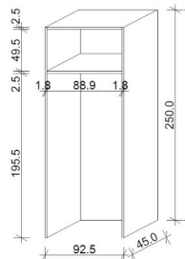  
 |  | 95x50x250cm | pcs | 15.00
 |  | 95x50x200cm | pcs | 1.00
4.000 | : | KS1  Ofice chair. The chair leans on a star of five movable wheels. A net backrest with adjustable lumbar support and adjustable height. Armrests are adjustable in height and width. The headrest for the head is adjustable in height and with tilting function. The chair is equipped with a mechanism for adjusting the height of the seat and seatback in several positions. The seat and backrest are made of molded sponge with the finishing of the fabric with the attest to the non-combustibility. The color is selected by the user. Calculation per piece. The price includes the purchase and installation. | 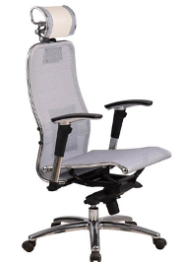
 |  |  | pcs | 27.00
5.000 | : | S2  Chair for guests. The chair is made of metal structures of circular cross-section and chrome. The finishing is the fire retardant fabric or eco-leather, in the color chosen by the user. The calculation is per piece. The price includes the purchase and installation. | 
 |  |  | pcs | 46.00
6.000 | : | RS1 150x75x75cm  Office desk is of dimensions 150x75x75. The table has the metal legs of rectangular cross section, which have the possibility of the passage of the cables through them. The tabletop is of chipboard 36mm thick, in the color selected by the user. The plate is coated with melamine foils resistant to scratching and staining. Calculation per piece. The price includes the purchase and installation. | 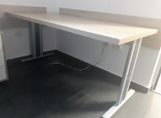  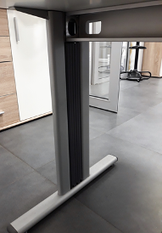
 |  |  | pcs | 27.00
7.000 | : | RS2 120x60x75cm  Office desk is of dimensions 120x60x75. The table has the metal legs of rectangular cross section, which have the possibility of the passage of the cables through them. The tabletop is of chipboard 36mm thick, in the color selected by the user. The plate is coated with melamine foils resistant to scratching and staining. Calculation per piece. The price includes the purchase and installation. | 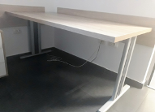  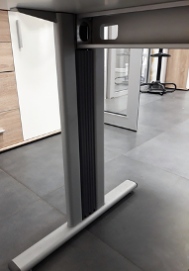
 |  |  | pcs | 13.00
8.000 | : | F1 40x50x60cm  Movable cassette under the desk with three drawers. Corps, the top and fron drawers are of the 18mm thick chipboard, in the color selected by the user. Drawer handles are made of aluminum. The central locking of all three drawers. Width of the drawers is 50cm and height 60cm. Calculation per piece. The price includes the purchase and installation. | 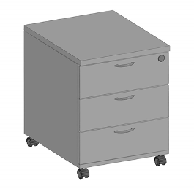
 |  |  | pcs | 27.00
9.000 | : | F2 80x50x60cm  Movable cassette next to the desk with three drawers. Corps is of the 36mm thick chipboard, drawers are of the 18mm thick chipboard, in the color selected by the user. Drawer handles are made of aluminum. The central locking of all three drawers. Width of the drawers is 50cm and height 60cm. Calculation per piece. The price includes the purchase and installation | 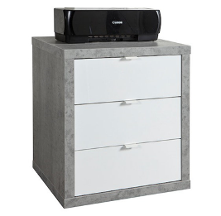
 |  |  | pcs | 9.00
10.000 | : | PL2 60x50x250cm  Office cabinet. Office cabinet is of dimensions 60x50x250. The construction of the cabinet is of the chipboard 18mm thick, design is selected by the user. The inside of the cabinet is with 5 shelves. The front of the cabinet are two doors to lock. Handles are made of plastic or aluminum. Calculation per piece . The price includes the purchase and installation. | 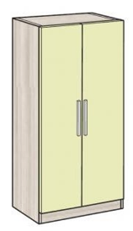
 |  |  | pcs | 6.00
11.000 | : | Plakar PL3 45x35x250cm  Office cabinet. Office cabinet is of dimensions 45x35x250. The construction of the cabinet is of the chipboard 18mm thick, design is selected by the user. The inside of the cabinet is with 5 shelves. The front of the cabinet are one door to lock. Handles are made of plastic or aluminum. Calculation per piece . The price includes the purchase and installation. | 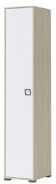
 |  |  | pcs | 1.00
12.000 | : | K1  Trash can | 
 |  |  | pcs | 35.00
13.000 | : | Metal stand for the computer cabinet. The structure is made from metal rods of circular cross-section and a metal stand on which is placed the computer cabinet. The complete element attaches to the tabletop from below, and from the floor is raised 20 cm in order to connect the cables from the floor box to the cabinet. Calculation per piece. The price includes the purchase and installation. | 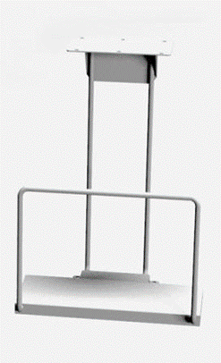
 |  |  | pcs | 27.00
14.000 | : | Partitions between the tables. Dimension of the partition is in the width 160x2x48 of the table.The partition consists of a metal frame with rectangular cross section and filling of chipboard 10mm thick. Decoration of the chipboard is selected by the user. On the profile is possible hang on accessories for office supplies. Calculation per piece. The price includes the purchase and installation. | 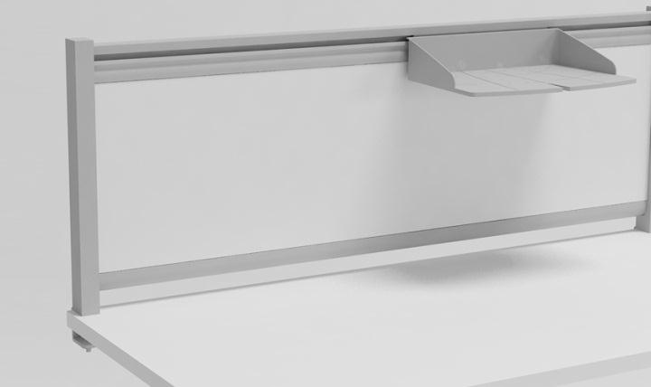  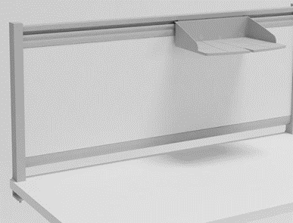
 |  |  | pcs | 25.00
15.000 | : | The kitchen is made of veneered chipboard. Design by the desire of the Investor. In the kitchen is fitted, hob cooker with two hotplates over the fitted fridge, and the round sink trough of stainless steel. The base units of the kitchen consist of a single element with a solid wing, and a wing for fitting fridge. Plinth is made of aluminum. The upper elements consist of two folding elements of the height of 90 cm with internal shelves. The height of lower and upper elements is 90cm. The depth of the lower elements is 60 cm, and of the upper 30cm. Calculation per meter of all elements of the kitchen. The price includes the purchase and installation. | 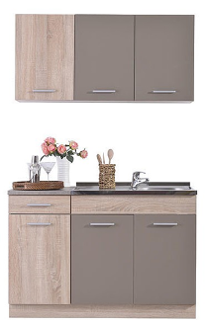
 |  | donji elementi | m' | 1.60
 |  | gornji elementi | m' | 1.60
16.000 | : | Supply and installation of one-piece round stainless steel sink 51cm. | 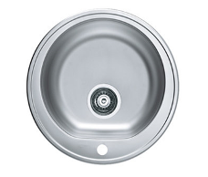
 |  |  | pcs | 1.00
17.000 | : | Supply and installation of the built in fridge of 60cm. Fridge is of the energy class A ++. As a part of the refrigerator there is the freezer. The total capacity is of 110L. | 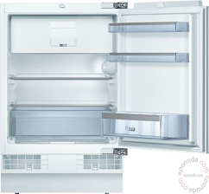
 |  |  | pcs | 1.00
18.000 | : | Supply and mounting of the hob of the cooker with two hotplates. Independent glass-ceramic fitting hob with sensor operation/handling. Hob dimensions 30cmx51cm. | 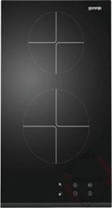
 |  |  | pcs | 1.00
19.000 | : | Movable metal archive, is made of sheet steel, on the surface coated in RAL 9002 color. Turning pieces can be placed on the finished floor, and if necessary, can be installed in the floor. The depth of the shelf is 30cm. Archive is combined with unilateral and bilateral racks. The number of the shelves in the height is 5. Before purchasing, check the allowed weight, precise measures, and confirm the schedule of the archive. Calculation per piece. The price includes the purchase and installation. | 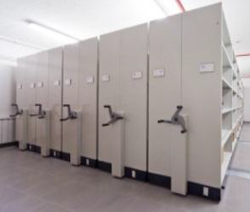
 |  | 120x30x190cm | pcs | 6.00
20.000 | : | White board for drawing | 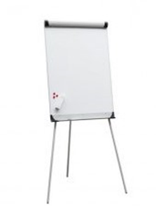
 |  | 70x110cm | pcs | 2.00
21.000 | : | Clothes coat hanger tip 1 | 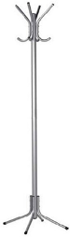
 |  |  | pcs | 13.00
22.000 | : | 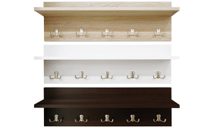  Clothes coat nanger tip 2 | pcs |  |  |  |  | 9.00

